
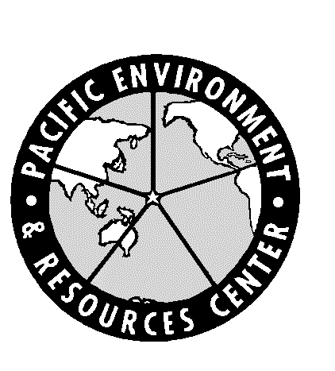

American Lands Alliance
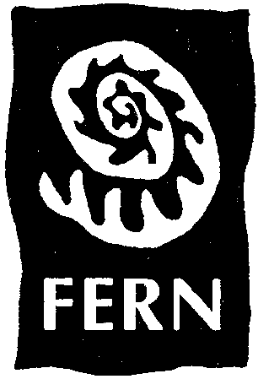

JOINT NGO STATEMENT: “DRAFT WTO MINISTERIAL TEXT HARMFUL FOR FORESTS”

3 December 1999 FOR IMMEDIATE RELEASE

Overnight the WTO working group on market access has gone from bad to worse. The text opens the way to substantially reduce tariffs and non-tariff measures in the forest products sector. Many non-tariff measures currently in place to protect forests, including log export bans, and labelling schemes could be affected. In addition, no mention is made of putting the necessary environmental safeguards into place. This negotiation is going ahead without a clear understanding of the impacts of trade liberalisation on forests and forest peoples. As it stands, the proposal will contribute to further destruction of the world’s forests.

In its report on trade and environment the WTO itself states that ‘trade can magnify the effects of bad policies, for instance if governments permitted unsustainable logging’. This should lead to the obvious conclusion that WTO members must strengthen environmental regulations before seeking greater trade liberalization. The current trade negotiations do exactly the opposite.

Today forests are disappearing at an alarming rate. Official figures state that 40 soccer fields of tropical forests are destroyed every minute and many of the boreal and temperate forests are being clear cut or replaced by plantations. Industrial logging is one of the main causes of forest destruction world-wide.

The chairman’s proposal advocates that negotiations on market access ‘shall cover all non-agricultural products’ and that the negotiations shall aim ‘at the reduction or elimination of non-tariff measures that restrict or distort trade’. The proposal also opens the door to accelerated tariff reduction in the forest sector. However, no mention is made of conducting a sustainability impact assessment prior to further negotiations or even safeguarding any forms of environmental protection.

Research shows that further trade liberalization by reducing tariffs and non-tariff measures will lead to an increase in logging. An increase in logging combined with bad forest management is a disastrous recipe for the world's forests and forest peoples.

The NGO community calls on WTO members to refrain from further negotiations.

Contact: Mark Vallianatos 206-953 0347

